CSE 219 — Signals and Linear Systems
Lec 3–4 · LTI Systems, Convolution, Causality and Stability
Lesson notes · Exam approach · TF practice with solutions · Quick notes (Anik Sir's portion)

How to Read These Notes
EXAM FOCUS | Exam importance, where it appears in the TF collection
MEMORIZE | Rules, tables and formulas to memorize
TRAP | Common mistakes and exam traps
EXAM-READY ANSWER | Model wording you can write in the exam
NOTE | Extra explanation / clarification
Grey box, monospace | Code, worked tables, derivations and hand-drawn sketches
Centered grey box | Formula to remember / final numerical result
Purple heading / ✔ green | Practice questions / their solutions

Contents
Exam Map — What the TF Papers Ask — system-property and convolution questions
Lesson 6 — Systems and Their Properties — linearity, time invariance (+ memory, causality, stability, invertibility)
Lesson 7 — Discrete Convolution as Polynomial Multiplication — reflect, shift, multiply, add
Lesson 8 — Impulse Response and the Convolution Sum / Integral — why y = x * h for every LTI system
Lesson 9 — Convolution Practice: DT, CT, Graphical, Interconnections — interval tables, cascades, parallel paths
Lesson 10 — Causality and Stability from h(t); h(t) of Simple Systems — h = 0 for t < 0; ∫|h| < ∞
Quick Notes — LTI and Convolution — merged revision notes + key diagrams
NOTE Slide numbers refer to Lecture-3-Linear-Time-Invariant-Systems-and-Convolution.pdf (59 slides, “Lec 3”) and Lecture-4-Convolution-Causality-and-Stability.pdf (70 slides, “Lec 4”). Memory, invertibility, interconnections and impulse responses of differential equations/circuits are textbook background (marked) — the EEE papers ask them every year.

Exam Map — What the TF Papers Ask
Convolution is the single most-asked Anik-part topic outside the transforms: 20 marks in CSE 219 2022-23 (Q8(a)), 15 in 2023-24 (Q1(b)), and a graphical convolution in nearly every EEE paper.
Session (paper) | Questions answered by this note
2023-24 (CSE 219) | Q1(b) h₁=δ[n]−δ[n−2], h₂=u[n−1], h₃=δ[n]−δ[n−1]; (h₁+h₂)*h₃: h_eq and y for x=u[n] (15) · Q3(b) Causal? stable? e^{−4t}u(3−t), e^{−6|t|}, te^{−t}u(t) (15)
2023-24 (EEE 211) | Q1(b) dy/dt + t²y = (2t+3)x: linear? time-invariant? (7) · Q1(c) Interconnection of h₁…h₅ (exponentials, δ): BIBO? y for x = e^{−t}u(t) (17) · Q2(a) Graphical convolution: x = rect on (1,2), h = triangle on (−1,1) (18) · Q2(b) Impulse response of a circuit in the time domain (17)
2022-23 (CSE 219) | Q8(a) Convolve x[n] = 3ⁿu[−n−1] + (1/3)ⁿu[n] with h[n] = (1/4)ⁿu[n+3] (20) · Q8(b) Causal? stable? h₁ = e^{2t}u(−2−t), h₂ = te^{−t}u(t) (10)
2022-23 (EEE 211) | Q5(b) LTI: x (V-shape) → y = rect; outputs for x(t−½)−x(t+½) and dx/dt (15) · Q7(b) x(t) = h(t) = t[u(t)−u(t−1)]: y(t) for all t (15) · Q8(b) dy/dt + t²y = (2t+3)x: linear? time-invariant? (15)
2021-22 (EEE 211) | Q2(a) Graphical convolution (triangle x, rectangle-plus-impulse h); analytic y (17) · Q2(b) y₁ = x₁h, y₂ = x₂h (triangle, trapezoid) [rest of wording cut off — illegible] (18)
2020-21 (EEE 211) | Q6(a) y = t·x(t+2): linear, causal, time-variant, memoryless, stable? (15) · Q6(b) Graphical convolution x = rect(t/2), h = r(t)u(1−t) (10) · Q6(c) Series RC, output v_R: impulse response by time-domain analysis (10)
2019-20 (EEE 211) | Q1 y = (1/3)∫x(τ)[δ(t−τ)+δ(t−τ+t₀)+δ(t−τ−t₀)]dτ: what it does; BIBO, linear, memoryless, causal, TI (35) · Q2 x = rect (0,2), h(t+1) = triangle: causal? y = x*h; what system does; z = x−x(t−4) (35)
2018-19 (EEE 211) | Q7(a) Linear system: x (rect) → y: causal, TI, memoryless? output for u(t)+u(t−1)−2u(t−2) (20) · Q7(b) h = u(t)−u(t−1), x = t²[u(t)−u(t−3)]: graphical convolution (15)
2018-19 (CSE 311) | Q4(b) Prove y = x*h for an LTI system using time-domain arguments only (17)
2017-18 (EEE 211) | Q6(a) Response y₁ to u(t)−u(t−1) given; response to x₂(t) (20) · Q6(b) y = k₁cos[k₂t + ∫₀ᵗ k₃x dτ]: TI, memoryless, causal, invertible, stable? (15) · Q7(a) Graphical convolution of x (Fig. 7a, 0–3) and h (−1 to 1) (20) · Q7(b) Cascade h₁ = te^{−t}u, h₂ = e^{−2t}u; x = u(t)−u(t−2)+δ(t+1): h, parallel equivalent, y (15)
2016-17 (EEE 211) | Q1(a) Memoryless/causal/stable: δ(t)−δ(t−2), 2rect(t/2), 2e^{−4t}u, (1−e^{−4t})u (15) · Q1(b) Interconnection h₁…h₅: overall h; y for x = u(t); stability (20) · Q3(c) RL circuit: impulse and step response (10)
2015-16 (EEE 301) | Q2(b) y = sin{x(t)+x(t−2)}: linear, TI, causal, memoryless, stable? (15) · Q3(b) h = (e^{−3t}−e^{−2t})u: zero-state response to u(t) and e^{−t}u(t) (15)
2014-15 (EEE 301) | Q2(a) y = sin(2t)log₁₀x(t); y = e^{−jωt}∫x e^{−jωτ}dτ: six properties (18) · Q2(b) y'+10y = 2x: h(t); output for x = Σ(−1)^k δ(t−5k) (17)
2014-15 (CSE 311) | Q7(a) Short notes: linear system, time-invariant system (10) · Q1(b) [L-3] Linearity and time invariance of an LTI system (10)
2013-14 (EEE 301) | Q2(b) y = ∫₀ᵗ e^{−(t−τ)}x(τ)dτ: LTI? impulse response; BIBO (17)
2012-13 (EEE 301) | Q1(c) y = x_e − x_o: invertible? inverse (11) · Q2(a) y = ∫_{−∞}^{2t−3}x dτ; y = ½|x(t)| − πt: six properties (18) · Q2(b) δ-systems and rect(t/2): y for x = Σ(−1)^k δ(t−10k) (17)
2011-12 (EEE 301) | Q7(a) y = 2x cos ω_ct: linear, TI, causal, stable? (8) · Q7(c) Importance of y = x*h in real life (4) · Q7(d) h₁ = δ(t+4), h₂ = δ(t−4) summed, then triangle h₃; x = rect(−1,1): g, y (13)
2010-11 (EEE 301) | Q6(b)(i) Graphical convolution: x = 1 on (0,2), h = triangle on (−1,1) (10) · Q6(b)(ii) Interconnection h₁…h₅: impulse response; causal, stable? (15) · Q7(a) y = At·x(t): linear, TI, causal, stable? (10)

EXAM FOCUS Learn in this order: (1) graphical CT convolution with an interval table (EEE every year) · (2) DT convolution of one-sided exponentials split into left/right parts (CSE 219 2022-23 Q8(a), 20 marks) · (3) causal? stable? from h(t) (2022-23 Q8(b), 2023-24 Q3(b)) · (4) interconnected systems: h_eq then y (2023-24 Q1(b), EEE 2023-24 Q1(c)) · (5) test linear / time-invariant / causal / memoryless / stable for a given equation.

Lesson 6 — Systems and Their Properties
Slides 2–11 (Lec 3) · memory, causality, stability, invertibility: textbook

1. What a System Is (sl. 3–5)
A system takes a whole input signal and produces a whole output signal: x(t) → S → y(t) (or x[n] → y[n]). It is not a number-to-number function.

2. Linearity and Time Invariance (sl. 7–11)
- Homogeneity: a x(t) → a y(t). Additivity: x₁ + x₂ → y₁ + y₂. Together: a x₁ + b x₂ → a y₁ + b y₂.
- Time invariance: x(t − t₀) → y(t − t₀): delaying the input only delays the output.
- LTI = both. Payoff: one special response (the impulse response) gives the output for every input.

3. Other Properties (textbook)
Property | Definition | Quick test
Memoryless | y(t) depends only on x(t) at the same t | any x(t − a), integral or derivative ⇒ memory
Causal | y(t) depends only on x(τ), τ ≤ t | look for x(t + a), x(−t), x(2t), upper limit > t
Stable (BIBO) | |x| ≤ B ⇒ |y| ≤ M | try x = constant, x = u(t); look for t·x, ∫x, 1/x, log x
Invertible | distinct inputs → distinct outputs | |x|, x², cos x, multiplying by something that can be 0 ⇒ not
Time-invariant | x(t − t₀) → y(t − t₀) | t appearing outside x(·), or x(2t), x(−t) ⇒ variant

MEMORIZE Linearity test: (1) zero input must give zero output (an added constant or −πt breaks it); (2) y must contain x only to the first power, inside no non-linear function. Time-invariance test: compute y₁ = S{x(t − t₀)} and y(t − t₀) separately and compare.

TRAP • y = x(2t), y = x(−t) are linear but time-variant and non-causal. • A system with a coefficient depending on t (t²y, t·x) is time-variant even though it is linear. • A differential equation is linear only with zero initial conditions.

Exam Approach
1. Linearity: apply a x₁ + b x₂ and compare with a y₁ + b y₂.
2. TI: compare S{x(t − t₀)} with y(t − t₀).
3. Causality/memory: list every time instant of x used to compute y(t).
4. Stability: find a bounded input with unbounded output (counterexample), or bound |y|.
5. Answer each property with one line of justification.

Practice — Lesson 6
(a) Actual — EEE 211 2019-20 Q1. (b) Actual — EEE 211 2023-24 Q1(b) / 2022-23 Q8(b). (c) Actual — EEE 211 2020-21 Q6(a). (d) Actual — EEE 211 2022-23 Q5(b). (e) Older papers, quick answers.
(a) y(t) = (1/3)∫x(τ)[δ(t − τ) + δ(t − τ + t₀) + δ(t − τ − t₀)]dτ. What does it do? Is it BIBO-stable, linear, memoryless, causal, time-invariant? (35)
(b) dy/dt + t²y = (2t + 3)x(t): linear? time-invariant?
(c) y(t) = t·x(t + 2): linear, causal, time-variant, memoryless, stable? (15)
(d) An LTI system maps x(t) = |t| (|t| ≤ 1, 0 elsewhere) to y(t) = 1 (|t| ≤ 1). Sketch the outputs for (i) x(t − ½) − x(t + ½), (ii) dx/dt. (15)
(e) (i) y = sin{x(t) + x(t − 2)}; (ii) y = sin(2t)log₁₀x(t); (iii) y = ∫_{−∞}^{2t−3}x dτ; (iv) y = ½|x(t)| − πt; (v) y = x_e − x_o; (vi) y = 2x cos ω_c t; (vii) y = At·x(t); (viii) y = ∫₀ᵗ e^{−(t−τ)}x(τ)dτ; (ix) y = k₁cos[k₂t + ∫₀ᵗ k₃x dτ].

✔ Solution
(a) Sifting each impulse: y(t) = (1/3)[x(t) + x(t + t₀) + x(t − t₀)] — a three-point moving average (smoothing / low-pass filter). Linear: yes (sum of shifted copies). Time-invariant: yes (x(t − a) gives y(t − a)); h(t) = (1/3)[δ(t) + δ(t + t₀) + δ(t − t₀)]. Memoryless: no (uses t ± t₀). Causal: no for t₀ ≠ 0 (uses x(t + t₀); h ≠ 0 at t = −t₀). BIBO-stable: yes, |y| ≤ (1/3)(B + B + B) = B (∫|h| = 1).
(b) Linear: if x₁ → y₁, x₂ → y₂ then a x₁ + b x₂ satisfies the equation with a y₁ + b y₂ (all terms are first power in x and y, zero initial state) ⇒ linear. Time-variant: with input x(t − t₀) the solution y₁ obeys y₁′ + t²y₁ = (2t + 3)x(t − t₀), while y(t − t₀) obeys y′ + (t − t₀)²y = (2t − 2t₀ + 3)x(t − t₀) — different coefficients ⇒ time-variant.
(c) Linear (a x₁ + b x₂ → t(a x₁ + b x₂)(t + 2)). Non-causal (uses x(t + 2), the future). Time-variant: S{x(t − t₀)} = t x(t − t₀ + 2) ≠ y(t − t₀) = (t − t₀)x(t − t₀ + 2). Has memory (uses t + 2). Unstable: x = 1 gives y = t → ∞.
(d) Use linearity and time invariance on the given pair: (i) output = y(t − ½) − y(t + ½) = −1 on (−3/2, −½), 0 on (−½, ½), +1 on (½, 3/2). (ii) Differentiation commutes with an LTI system (derivative = limit of a difference of shifted inputs), so output = dy/dt = δ(t + 1) − δ(t − 1).
(e) linear TI causal memoryless stable invertible
(i) no yes yes no yes no
(ii) no no yes yes no no (sin 2t = 0 at some t)
(iii) yes no no no no yes (y′(t) = 2x(2t − 3))
(iv) no no yes yes no no (|x|)
(v) = x(−t) yes no no no yes yes (inverse = itself)
(vi) yes no yes yes yes no (cos ω_c t = 0)
(vii) yes no yes yes no no (t = 0)
(viii) yes for inputs starting at t ≥ 0 it is LTI with h = e^{−t}u(t); ∫|h| = 1 ⇒ stable
(ix) no no yes no yes (|y| ≤ |k₁|)

Lesson 7 — Discrete Convolution as Polynomial Multiplication
Slides 12–31 (Lec 3)
Multiply A(z) = 1 + 3z + 2z² + 5z³ + 4z⁴ by B(z) = 2 − z + 4z² + z³ + 3z⁴. The coefficient of z⁴ collects every product whose powers add to 4 (sl. 14–15):
c[4] = a0b4 + a1b3 + a2b2 + a3b1 + a4b0 = 1·3 + 3·1 + 2·4 + 5·(−1) + 4·2 = 17

c[n] = (a * b)[n] = Σₖ a[k] b[n − k]
b[n − k] means: reflect b (b[−k]), then shift it right by n, multiply the samples that line up, and add (sl. 17–22). Convolution is commutative: a * b = b * a (polynomial product order does not matter, sl. 29–30).
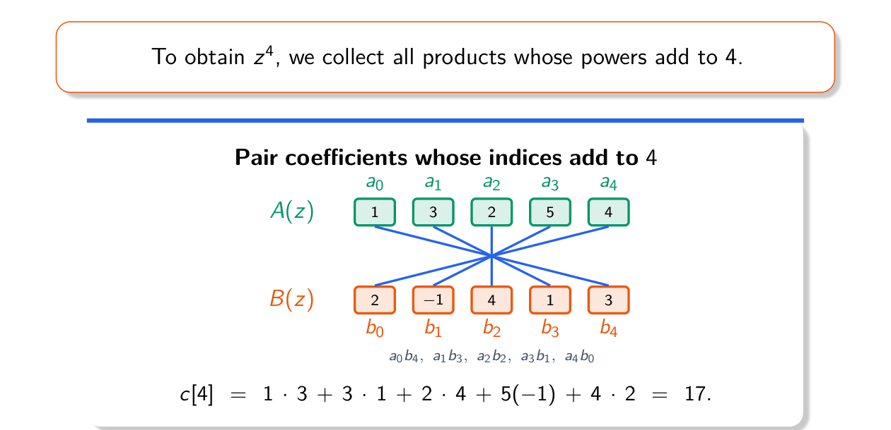
Figure 7.1 — The z⁴ coefficient comes from criss-crossed pairings (Lec 3, sl. 15)

Worked Example (sl. 23–28)
x = {1, 2, 1, 1}, h = {1, 1, −1, 2} (both start at n = 0)
n: 0 1 2 3 4 5 6
y: 1 3 2 2 4 1 2
e.g. y[3] = 1·2 + 2·(−1) + 1·1 + 1·1 = 2; length = 4 + 4 − 1 = 7

MEMORIZE Finite sequences: start index = sum of start indices, length = L + M − 1, Σy = (Σx)(Σh) (quick check: 5 × 3 = 15 = 1+3+2+2+4+1+2 ✓). Fast hand method: multiply as polynomials, or use a sliding-strip table.

Exam Approach
1. Write both sequences with their index ranges.
2. Reflect h, slide one step at a time, multiply-add the overlap (or multiply polynomials).
3. Check: start index, length, and Σy = Σx·Σh.

Practice — Lesson 7
(a) Practice set 3.1. (b) Practice set 3.3. (c) Constructed.
(a) x = {1, 2} (n = 0, 1), h = {1, −1, 2} (n = 0, 1, 2). Find y = x * h.
(b) x[n] is zero except x[−1] = 2, x[0] = −1, x[2] = 3. Write x as shifted impulses and y in terms of h.
(c) Find the coefficient of z⁵ in A(z)B(z) of the slide example.

✔ Solution
(a) (1 + 2z)(1 − z + 2z²) = 1 + z + 0z² + 4z³ → y = {1, 1, 0, 4}, n = 0…3. Check Σ: 3·2 = 6 ✓.
(b) x[n] = 2δ[n + 1] − δ[n] + 3δ[n − 2] ⇒ y[n] = 2h[n + 1] − h[n] + 3h[n − 2].
(c) c[5] = a1b4 + a2b3 + a3b2 + a4b1 = 3·3 + 2·1 + 5·4 + 4·(−1) = 27.

Lesson 8 — Impulse Response and the Convolution Sum / Integral
Slides 32–57 (Lec 3), 2–9 (Lec 4)
Philosophy (sl. 34–37): solve for the simplest input, break any input into such pieces, combine the answers (like counting factors of 72 = 2³·3²: (3+1)(2+1) = 12).
- Simplest input: δ[n]. Its output is the impulse response h[n] — the system's signature (sl. 38–40).
- Echo system: h[n] = u[n] (equal echoes forever); h = αⁿu[n], 0 < α < 1: fading echoes, larger α fades slower (sl. 42–44). Pure delay by 3: h[n] = δ[n − 3] (CT: δ(t − 3)) (sl. 45–46).
- Input x = δ[n] + 2δ[n−1] − δ[n−2] + δ[n−3] into h = u[n]: y = u[n] + 2u[n−1] − u[n−2] + u[n−3] = 1, 3, 2, 3, 3, … (sl. 47–51).

Derivation (sl. 52–57) — exam-ready
1. Any input is a sum of shifted, scaled impulses: x[n] = Σₖ x[k] δ[n − k]
2. Time invariance: δ[n − k] → h[n − k]
3. Homogeneity: x[k]δ[n − k] → x[k]h[n − k]
4. Additivity: y[n] = Σₖ x[k] h[n − k] = (x * h)[n]
CT (textbook): x(t) = ∫ x(τ) δ(t − τ) dτ (sifting) → same steps with ∫ ⇒ y(t) = ∫ x(τ) h(t − τ) dτ

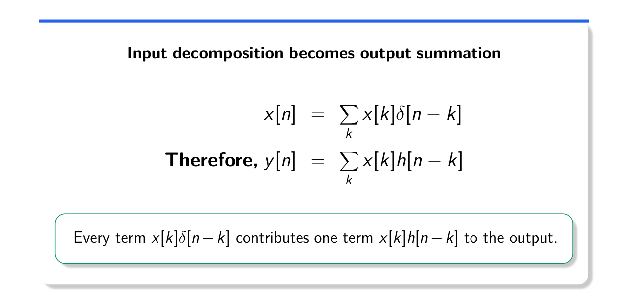
Figure 8.1 — Input decomposition becomes output summation (Lec 3, sl. 55)
CT convolution (Lec 4, sl. 6–8): y(t) = ∫ x(τ)h(t − τ)dτ. Fix t, slide h(t − τ) along τ, integrate the product over the overlap. Same recipe: choose the output point, reflect and shift, multiply and add.
EXAM-READY ANSWER Why convolution matters in real life (EEE 301 2011-12 Q7(c)): once h(t) is measured (hit the system with an impulse — clap in a hall, tap a structure), the output for every input is x * h without re-solving the system: reverb/echo simulation, sensor smoothing (moving average), image blurring and sharpening, channel modelling in communications.

Practice — Lesson 8
(a) Actual — CSE 311 2018-19 Q4(b). (b) Actual — EEE 301 2011-12 Q7(c). (c) Practice set 4.9–4.11.
(a) Prove that for an input x(t), the output of an LTI system with impulse response h(t) is y = x * h, using only time-domain arguments. (17)
(b) Mention the importance of y = x * h in real-life applications. (4)
(c) How can convolution simulate a large hall, smooth sensor readings, and add an echo?

✔ Solution
(a) By the sifting property x(t) = ∫x(τ)δ(t − τ)dτ: x is a continuum of impulses of strength x(τ)dτ at t = τ. Let δ(t) → h(t). Time invariance: δ(t − τ) → h(t − τ). Homogeneity: x(τ)dτ δ(t − τ) → x(τ)dτ h(t − τ). Additivity (the integral is a limit of sums): y(t) = ∫x(τ)h(t − τ)dτ = x(t) * h(t). Every step uses only L and TI.
(b) See the EXAM-READY ANSWER above.
(c) Hall: record the hall's impulse response (a clap or balloon pop) and convolve the dry voice with it. Smoothing: convolve readings with a short averaging kernel h = (1/M)Σδ[n − k], k = 0…M−1. Echo: h[n] = δ[n] + aδ[n − D]; D sets the delay, a (< 1) the strength; more taps (a, a², …) give repeated echoes.

Lesson 9 — Convolution Practice: DT, CT, Graphical, Interconnections
Slides 10–52 (Lec 4) · interconnections: textbook

1. Slide Examples
Example | Signals | Result
Ex 2.2 (sl. 11–19) | x = {0.5, 2}, h = {1, 1, 1} | y = {0.5, 2.5, 2.5, 2}, n = 0…3
Ex 2.3 (sl. 20–27) | αⁿu[n] * u[n] | (1 − α^{n+1})/(1 − α) u[n] → 1/(1 − α)
Ex 2.5 (sl. 28–34) | 2ⁿu[−n] * u[n] | 2^{n+1} (n < 0); 2 (n ≥ 0)
Ex 2.6 (sl. 35–40) | e^{−at}u(t) * u(t) | (1/a)(1 − e^{−at})u(t)
Ex 2.10 (sl. 42–47) | [(½)ⁿu[n] + 2ⁿu[−n]] * u[n] | 2^{n+1} (n < 0); 4 − 2^{−n} (n ≥ 0)
sl. 48–52 | eᵗu(−t) * e^{−t}u(t) | ½e^{t} (t < 0); ½e^{−t} (t ≥ 0) = ½e^{−|t|}

Key step of every infinite-length example: find the overlap. For x[k] = αᵏu[k] and h[n − k] = u[n − k], x is nonzero for k ≥ 0 and h[n − k] for k ≤ n ⇒ overlap 0 ≤ k ≤ n (empty for n < 0). Then sum a geometric series:
Σ_{k=0}^{n} αᵏ = (1 − α^{n+1})/(1 − α) Σ_{k=−∞}^{m} βᵏ = β^{m}/(1 − 1/β) (β > 1)
Distributivity (sl. 41): x * (h₁ + h₂) = x * h₁ + x * h₂ — split a two-sided input into its left and right parts, convolve separately, add.
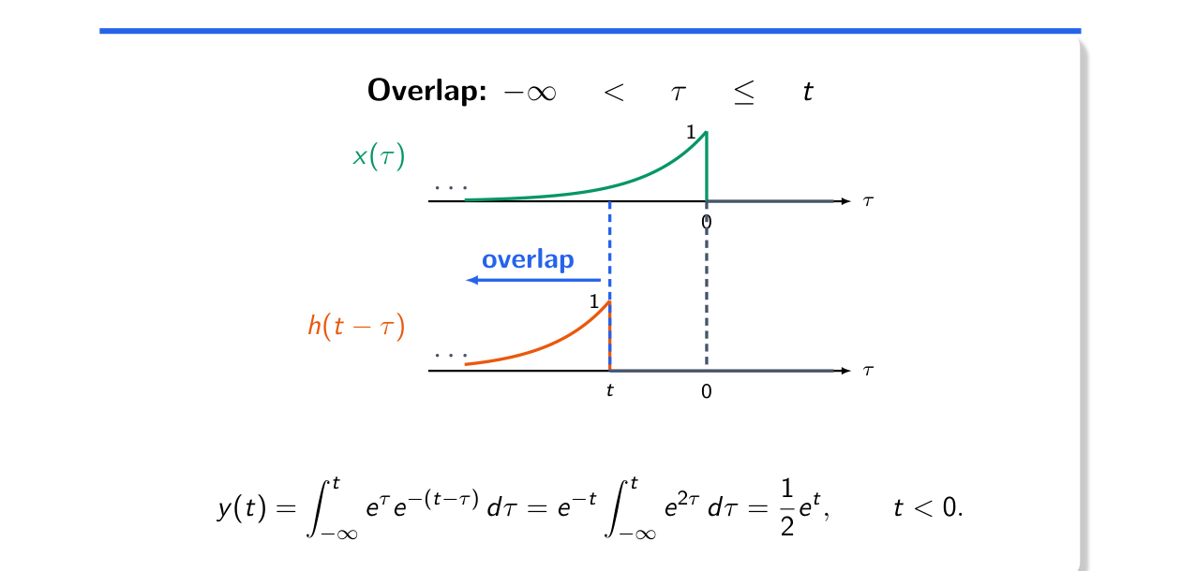
Figure 9.1 — CT overlap for t < 0 ends at τ = t (Lec 4, sl. 50)

2. Graphical CT Convolution — the Interval Table
- Choose the simpler signal to flip (often the rectangle).
- Write the edges of h(t − τ) as functions of t; list the t-intervals where the overlap changes (edge of one passes edge of the other).
- On each interval write the integral limits and evaluate; check continuity at interval ends.
- Useful shortcut: x = rect on (a, b) ⇒ y(t) = ∫_{t−b}^{t−a} h(s)ds = H(t − a) − H(t − b), H = running integral of h.

3. Interconnections (textbook)
Cascade: h = h₁ * h₂ Parallel: h = h₁ + h₂ δ(t − a) * h(t) = h(t − a)
Useful pair: e^{−at}u(t) * e^{−bt}u(t) = [e^{−bt} − e^{−at}]/(a − b) · u(t) (a ≠ b)
e^{−at}u(t) * e^{−at}u(t) = t e^{−at}u(t)

TRAP • Do not forget the n < 0 (t < 0) region: one-sided signals often give a nonzero left tail (Ex 2.5). • u[n + 3] starts at n = −3: shift the summation limits. • Interval ends are where the edges meet — write them as t-values before integrating.

Exam Approach
1. Sketch both signals; decide which to flip.
2. Find the overlap limits as functions of n (or t) and split into cases.
3. Evaluate each sum/integral; geometric series for exponentials.
4. Check continuity at case boundaries, the support (sum of supports) and the area (∫y = ∫x·∫h).

Practice — Lesson 9
(a) Actual — CSE 219 2022-23 Q8(a). (b) Actual — CSE 219 2023-24 Q1(b). (c) Actual — EEE 211 2023-24 Q1(c).
(a) Convolve x[n] = 3ⁿu[−n − 1] + (1/3)ⁿu[n] with h[n] = (1/4)ⁿu[n + 3]. (20)
(b) h₁ = δ[n] − δ[n − 2] and h₂ = u[n − 1] in parallel, followed by h₃ = δ[n] − δ[n − 1]. (i) h_eq; (ii) y for x = u[n]. (15)
(c) x feeds three paths — h₁; h₂ followed by h₃; h₄ — which are added and passed through h₅. h₁ = e^{−2t}u, h₂ = e^{−2t}u, h₃ = e^{−t}u, h₄ = δ(t), h₅ = e^{−3t}u. Using time-domain techniques: (i) is it BIBO stable? (ii) y for x = e^{−t}u(t). (17)

✔ Solution
(a) Split x = x₁ + x₂ (distributivity), x₁ = 3ⁿu[−n−1], x₂ = (1/3)ⁿu[n]. h[n − k] = (¼)^{n−k} is nonzero for k ≤ n + 3.
y1[n] = Σ_{k ≤ min(−1, n+3)} 3^k (1/4)^{n−k} = 4^{−n} Σ 12^k
n ≤ −4: upper limit n+3: 4^{−n}·12^{n+3}·(12/11) = 256·3^{n+4}/11
n ≥ −3: upper limit −1: 4^{−n}·(1/12)/(1 − 1/12) = 4^{−n}/11
y2[n] = Σ_{k=0}^{n+3} (1/3)^k (1/4)^{n−k} (n ≥ −3) = 4^{−n} Σ_{k=0}^{n+3} (4/3)^k
= 4^{−n}·[(4/3)^{n+4} − 1]/(1/3) = 256·3^{−(n+3)} − 3·4^{−n}; 0 for n < −3

y[n] = 256·3^{n+4}/11 n ≤ −4
256·3^{−(n+3)} − (32/11)·4^{−n} n ≥ −3
Values: y[−4] = 23.27, y[−3] = 69.82, y[−2] = 38.79, y[−1] = 16.81, y[0] = 6.57, y[1] = 2.43

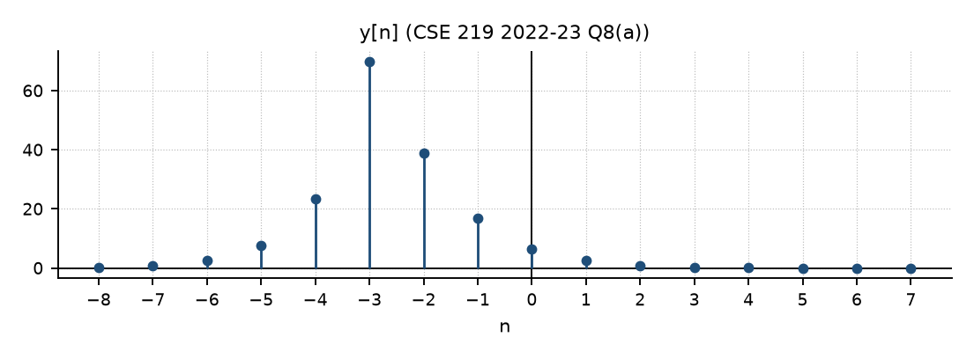
Figure 9.2 — Output of CSE 219 2022-23 Q8(a): rises as 3ⁿ on the left, peaks at n = −3, decays on the right
(b) Parallel then cascade: h_eq = (h₁ + h₂) * h₃. u[n − 1] * (δ[n] − δ[n − 1]) = u[n − 1] − u[n − 2] = δ[n − 1]; (δ[n] − δ[n − 2]) * (δ[n] − δ[n − 1]) = δ[n] − δ[n−1] − δ[n−2] + δ[n−3]. Adding:
(i) h_eq[n] = δ[n] − δ[n − 2] + δ[n − 3]
(ii) y[n] = u[n] * h_eq = u[n] − u[n − 2] + u[n − 3]
n: <0 0 1 2 3 4 …
y: 0 1 1 0 1 1 …

(c) Middle path: h₂ * h₃ = e^{−2t}u * e^{−t}u = (e^{−t} − e^{−2t})u. Sum of the three paths: g = e^{−2t}u + (e^{−t} − e^{−2t})u + δ(t) = δ(t) + e^{−t}u(t). Then
h_eq = g * h5 = e^{−3t}u + e^{−t}u * e^{−3t}u = e^{−3t}u + ½(e^{−t} − e^{−3t})u = ½(e^{−t} + e^{−3t})u(t)
(i) ∫|h_eq| dt = ½(1 + 1/3) = 2/3 < ∞ ⇒ BIBO stable (also causal)
(ii) y = e^{−t}u * ½(e^{−t} + e^{−3t})u = ½ t e^{−t}u + ¼(e^{−t} − e^{−3t})u
y(t) = [ ½ t e^{−t} + ¼ e^{−t} − ¼ e^{−3t} ] u(t)

Practice — Lesson 9 (continued) — Graphical Convolution
(d) Actual — EEE 211 2023-24 Q2(a). (e) Actual — EEE 211 2019-20 Q2. (f) Actual — EEE 211 2021-22 Q2(a). (g) Actual — EEE 211 2020-21 Q6(b). (h) Actual — EEE 211 2022-23 Q7(b). (i) Older: EEE 301 2010-11 Q6(b)(i), EEE 211 2018-19 Q7(b), EEE 301 2011-12 Q7(d), 2012-13 Q2(b), 2015-16 Q3(b).
(d) x = 1 on (1, 2); h = triangle on (−1, 1), peak 1 at 0. Find y = x * h graphically. (18)
(e) x = 1 on (0, 2); h(t + 1) is the triangle on (−1, 1). (i) Causal? (ii) y = x * h. (iii) What does the system do? (iv) Output for z = x(t) − x(t − 4). (35)
(f) x = triangle on (0, 2), peak 1 at t = 1; h = 2 on (0, 1) plus an impulse δ(t − 3). Find y graphically and analytically. (17)
(g) x = rect(t/2), h = r(t)u(−t + 1). Find y. (10)
(h) x(t) = h(t) = t[u(t) − u(t − 1)]: find y(t) for all t. (15)
(i) Older papers (see solutions).

✔ Solution
(d) Flip the rectangle: y(t) = ∫_{t−2}^{t−1} tri(s)ds. Let F(s) = running integral of the triangle: 0 (s < −1), (s + 1)²/2 (−1..0), 1 − (1 − s)²/2 (0..1), 1 (s > 1). y = F(t − 1) − F(t − 2):
interval overlap y(t)
t < 0 none 0
0 ≤ t ≤ 1 left edge of tri t²/2
1 ≤ t ≤ 2 rect covers the peak −t² + 3t − 3/2 (max 3/4 at t = 1.5)
2 ≤ t ≤ 3 right edge (3 − t)²/2
t > 3 none 0 check: area = 1·1 = 1 ✓

(e) (i) h(t) = triangle on (0, 2) with peak 1 at t = 1 ⇒ h = 0 for t < 0 ⇒ causal. (ii) y = F(t − 1) − F(t − 3):
0 ≤ t ≤ 1: t²/2 1 ≤ t ≤ 2: 1 − (2 − t)²/2 2 ≤ t ≤ 3: 1 − (t − 2)²/2 3 ≤ t ≤ 4: (4 − t)²/2
(iii) a smoothing (low-pass, triangular-weighted moving average) filter with a delay of 1: the sharp
edges of x become smooth S-curves, the duration grows from 2 to 4, peak y(2) = 1, area 2·1 = 2 ✓
(iv) z → y(t) − y(t − 4): the pulse above on [0, 4] followed by its negative on [4, 8]

(f) h = 2[u(t) − u(t − 1)] + δ(t − 3). The impulse part gives x(t − 3) (triangle on (3, 5)). The rectangle part: 2∫_{t−1}^{t} x(s)ds:
0 ≤ t ≤ 1: t² 1 ≤ t ≤ 2: −2t² + 6t − 3 2 ≤ t ≤ 3: (3 − t)²
plus 3 ≤ t ≤ 4: t − 3, 4 ≤ t ≤ 5: 5 − t (the delayed triangle)
y(t) = t²[u(t) − u(t−1)] + (−2t² + 6t − 3)[u(t−1) − u(t−2)] + (3−t)²[u(t−2) − u(t−3)] + x(t − 3)

(g) x = 1 on (−1, 1); h = t on (0, 1). y = ∫_{t−1}^{t+1}h(s)ds = H(t + 1) − H(t − 1), H(s) = s²/2 on [0,1], ½ after:
−1 ≤ t ≤ 0: (t + 1)²/2 0 ≤ t ≤ 1: 1/2 1 ≤ t ≤ 2: 1/2 − (t − 1)²/2 else 0

(h) Overlap 0 ≤ τ ≤ t for 0 ≤ t ≤ 1 and t − 1 ≤ τ ≤ 1 for 1 ≤ t ≤ 2:
0 ≤ t ≤ 1: ∫₀ᵗ τ(t − τ)dτ = t³/6
1 ≤ t ≤ 2: ∫_{t−1}^{1} τ(t − τ)dτ = −t³/6 + t − 2/3 (continuous: 1/6 at t = 1, 0 at t = 2)
otherwise 0

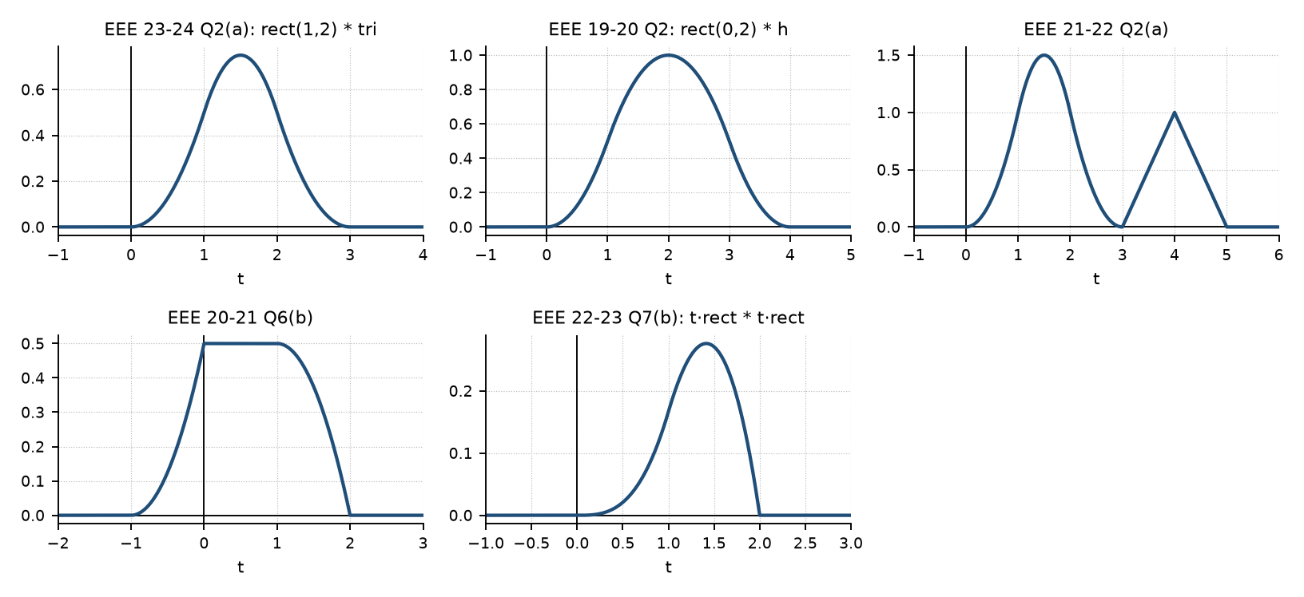
Figure 9.3 — Outputs of the graphical-convolution questions (d)–(h)
(i) EEE 301 2010-11 Q6(b)(i): x = 1 on (0, 2), h = tri: (t+1)²/2 [−1,0]; 1 − (1−t)²/2 [0,1]; 1 − (t−1)²/2 [1,2]; (3−t)²/2 [2,3]. EEE 211 2018-19 Q7(b): x = t² on (0, 3), h = 1 on (0, 1): y = t³/3 [0,1]; [t³ − (t−1)³]/3 [1,3]; [27 − (t−1)³]/3 [3,4]. EEE 301 2011-12 Q7(d): g = x(t + 4) + x(t − 4); y = P(t + 4) + P(t − 4) with P = rect(−1,1) * tri = (t+2)²/2 [−2,−1], 1 − t²/2 [−1,1], (2−t)²/2 [1,2]. EEE 301 2012-13 Q2(b): δ(t+1)δ(t−1) = δ(t), so h = δ(t) + rect(t/2); y = Σ(−1)ᵏ[δ(t − 10k) + rect((t − 10k)/2)]. EEE 301 2015-16 Q3(b): step response −1/6 + ½e^{−2t} − ⅓e^{−3t}; response to e^{−t}u: −½e^{−t} + e^{−2t} − ½e^{−3t} (all × u(t)). EEE 211 2017-18 Q7(b): h₁ h₂ = (t − 1)e^{−t} + e^{−2t} = t e^{−t} − e^{−t} + e^{−2t} (three parallel branches).

Lesson 10 — Causality and Stability from h(t); h(t) of Simple Systems
Slides 53–69 (Lec 4) · impulse responses of differential equations and circuits: textbook
causal ⇔ h(t) = 0 for t < 0 (h[n] = 0, n < 0)
BIBO stable ⇔ ∫|h(t)|dt < ∞ (Σ|h[n]| < ∞)
Why (sl. 58): |y(t)| = |∫h(τ)x(t − τ)dτ| ≤ B∫|h(τ)|dτ. Periodic h (sl. 60–62): a nonzero periodic h cannot be causal (any nonzero value repeats at t₀ − kT < 0) and cannot be stable (area A per period, infinitely many periods).
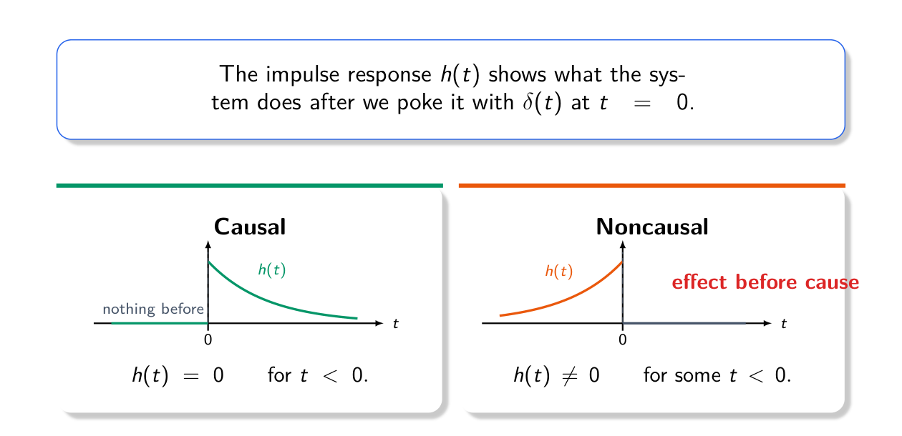
Figure 10.1 — Causal vs non-causal impulse responses (Lec 4, sl. 55)
Slide examples: h1 = e^{2t}u(−2 − t): nonzero for t ≤ −2 ⇒ non-causal; ∫_{−∞}^{−2} e^{2t} = e^{−4}/2 ⇒ stable
h2 = t e^{−t}u(t): causal; ∫₀^∞ t e^{−t} dt = 1 ⇒ stable
Minimum delay to make e^{−2t}u(t + 2) causal (sl. 68–69): start −2 + a ≥ 0 ⇒ a ≥ 2

Impulse Response of a First/Second-Order System (textbook)
y′ + a y = b x ⇒ h(t) = b e^{−at}u(t)
Series RC, output v_C: RC v′ + v = x ⇒ h_C = (1/RC) e^{−t/RC} u(t)
Series RC, output v_R = x − v_C ⇒ h_R = δ(t) − (1/RC) e^{−t/RC} u(t)
Series L, shunt C (output v_C): LC y″ + y = x ⇒ h = ω₀ sin(ω₀t) u(t), ω₀ = 1/√(LC)
Method: for t > 0 solve the homogeneous equation; the impulse sets the initial conditions
(order n: h^{(n−1)}(0⁺) = 1/a_n, lower derivatives 0; a δ in h appears if numerator order = n)

TRAP • u(3 − t) and u(−2 − t) extend to −∞: non-causal. • e^{−4t}u(3 − t) grows as t → −∞: unstable. • Even e^{−6|t|} is non-causal (nonzero for t < 0) though stable.

Exam Approach
1. Causality: find the support of h; any nonzero part at t < 0 ⇒ non-causal.
2. Stability: compute ∫|h| (split piecewise); exponentials: check decay in both directions.
3. For an equation/circuit: get the ODE, solve the homogeneous part for t > 0, impose the impulse jump conditions.

Practice — Lesson 10
(a) Actual — CSE 219 2022-23 Q8(b). (b) Actual — CSE 219 2023-24 Q3(b). (c) Actual — EEE 211 2023-24 Q2(b). (d) Actual — EEE 211 2020-21 Q6(c). (e) Older: EEE 211 2016-17 Q1(a), Q3(c); EEE 301 2014-15 Q2(b).
(a) Causal? stable? h₁ = e^{2t}u(−2 − t), h₂ = te^{−t}u(t). (10)
(b) Causal and/or stable? (i) e^{−4t}u(3 − t); (ii) e^{−6|t|}; (iii) te^{−t}u(t). (15)
(c) Find, in the time domain, the impulse response of the LC circuit (series L, output across shunt C). (17)
(d) RC series circuit, output v_R, initially relaxed: h(t) by time-domain analysis. (10)
(e) (i) memoryless/causal/stable: δ(t) − δ(t − 2), 2rect(t/2), 2e^{−4t}u, (1 − e^{−4t})u; (ii) y′ + 10y = 2x: h(t) and output for x = Σ_{k=−2}²(−1)ᵏδ(t − 5k).

✔ Solution
(a) h₁: nonzero for t ≤ −2 ⇒ non-causal; ∫_{−∞}⁻²e^{2t}dt = e⁻⁴/2 < ∞ ⇒ stable. h₂: zero for t < 0 ⇒ causal; ∫₀^∞ te^{−t}dt = 1 ⇒ stable.
(b) (i) nonzero for all t < 3 ⇒ non-causal; ∫_{−∞}³e^{−4t}dt = ∞ (grows as t → −∞) ⇒ unstable. (ii) nonzero for t < 0 ⇒ non-causal; ∫e^{−6|t|} = 2·(1/6) = 1/3 ⇒ stable. (iii) causal, ∫ = 1 ⇒ stable.
(c) KVL: x = L di/dt + y, i = C dy/dt ⇒ LC y″ + y = x. For t > 0 with x = δ: LC h″ + h = 0 ⇒ h = A cos ω₀t + B sin ω₀t, ω₀ = 1/√(LC). Integrating the equation over (0⁻, 0⁺): LC[h′(0⁺) − 0] = 1 and h(0⁺) = 0. So A = 0, Bω₀ = 1/LC ⇒ B = ω₀. h(t) = (1/√(LC)) sin(t/√(LC)) u(t) — an undamped oscillation (marginally unstable).
(d) v_R = x − v_C, RC v_C′ + v_C = x. For x = δ: v_C jumps to 1/RC and decays: h_C = (1/RC)e^{−t/RC}u(t). Hence h(t) = δ(t) − (1/RC)e^{−t/RC}u(t) (the resistor passes the impulse instantly, then the capacitor's charge discharges through it).
(e) (i) δ(t) − δ(t − 2): memory, causal, stable; 2rect(t/2): memory, non-causal, stable; 2e^{−4t}u: memory, causal, stable (∫ = ½); (1 − e^{−4t})u: memory, causal, unstable (∫ → ∞). (ii) h = 2e^{−10t}u(t) (≈ 0 well before 5 s, so responses do not overlap); y = Σ_{k=−2}² 2(−1)ᵏe^{−10(t−5k)}u(t − 5k): five decaying spikes of alternating sign at t = −10, −5, 0, 5, 10.

Quick Notes — LTI and Convolution
Revision points for Lessons 6–10.

L6 · System Properties
- Linear: a x₁ + b x₂ → a y₁ + b y₂ (zero in → zero out). TI: x(t − t₀) → y(t − t₀).
- t outside x(·), x(2t), x(−t) ⇒ time-variant. x(t + a), x(−t) ⇒ non-causal.
- (1/3)[x(t) + x(t ± t₀)]: moving average — LTI, stable, non-causal.

L7 · Discrete Convolution
- c[n] = Σ a[k]b[n − k] = polynomial coefficients; length L + M − 1; Σy = ΣxΣh.
- {1,2,1,1} * {1,1,−1,2} = {1,3,2,2,4,1,2}.

L8 · Impulse Response
- x = Σx[k]δ[n − k] → y = Σx[k]h[n − k] (TI + homogeneity + additivity).
- Delay by 3: h = δ[n − 3]. Echo: h = u[n] or αⁿu[n].

L9 · Convolution Practice
- αⁿu * u = (1 − α^{n+1})/(1 − α) u; e^{−at}u * u = (1 − e^{−at})/a u.
- e^{−at}u * e^{−bt}u = (e^{−bt} − e^{−at})/(a − b) u; equal a ⇒ t e^{−at}u.
- Cascade: convolve; parallel: add; δ(t − a) * h = h(t − a).
- Rect on (a, b): y = H(t − a) − H(t − b). Interval table + continuity check.

L10 · Causality, Stability
- Causal ⇔ h = 0 for t < 0; stable ⇔ ∫|h| < ∞. Periodic h: neither.
- y′ + ay = bx ⇒ h = b e^{−at}u. LC ⇒ ω₀ sin ω₀t u(t). RC, v_R ⇒ δ − (1/RC)e^{−t/RC}u.

Key Diagrams to Reproduce
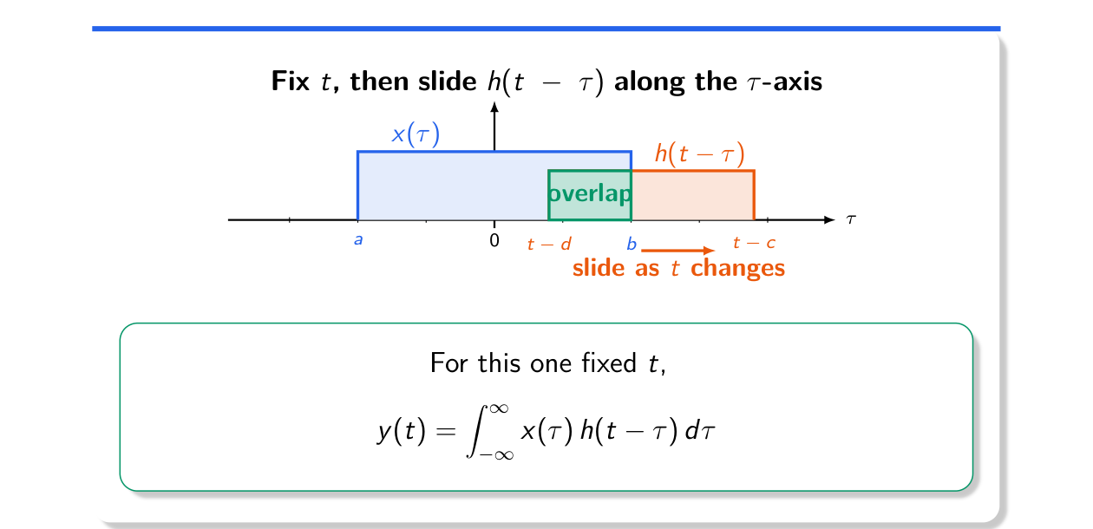
CT convolution: slide h(t − τ) along τ and integrate the overlap (Lec 4, sl. 7)

